**ALCOHOL INTAKE AND SLEEP DURATION AMONGST US ARMED FORCES VETERANS IN 2016: FINDINGS FROM THE BEHAVIORAL RISK FACTOR SURVEILLANCE SYSTEM (BRFSS)**

**ABSTRACT**

**Objective:** This study sought to identify if there was an association between alcohol intake and sleep duration in the United States Armed Forces veterans using the data obtained from the BRFSS 2016 database.   
**Method:** This is a cross-sectional study based on the data obtained from the behavioral risk factor surveillance system (BRFSS, 2016). Veterans and the various categories were identified based on specific questions asked in the survey. Data extraction, sub-setting, analysis and development of linear regression models was accomplished using various R packages in the R studio **Results:** Out of 486303 individuals who were involved in the BRFSS data collection in 2016, the veteran subpopulation who had a valid response for sleep duration and alcohol intake was identified to contain 60109 (12.3%) individuals who were further classified into monthly, weekly and non-drinkers. Descriptive analysis and linear regression models were developed to check for an association between these variables and other confounders associated with sleep duration in humans. The observations and findings were presented using tables and plots.   
**Conclusion:** From the data analysis, there was no strong association shown between alcohol drinking (monthly and weekly) and sleep duration based on the final multiple regression model of the BRFSS data. Other confounding variables such as age, binge drinking, exercise status, and poor health showed a significant relationship with sleep duration.

Keywords: Sleep duration, Alcohol Intake, Linear regression models.

**INTRODUCTION**

There has been an increase in the published literature on alcoholism in veterans, this is in part due to the realization that the rate of alcoholism among adults in the United States is higher in the veterans than in non-veterans(Bohnert et al, 2012). Binge drinking, which is defined a having more than 5 alcoholic drink on one occasion, has been suggested to have an elevated prevalence in veterans(Bohnert et al, 2012). Bohnert et al suggested that military culture, combat experiences, and deployment could be a contributing factor to this increased alcohol intake in veterans. According to a published article by the United States Department of Veterans Affairs (VA) in 2016, which analyzed 55 million veterans' records from 1979 to 2014, indicates that an average of 20 veterans a day die from suicide in 2014 from 22 in 2010. This is usually related to mental health conditions that arise during and after service, including depression, anxiety, and PTSD(Galbicsek, C. 2018). Rather than seek help and professional advice, reports show that only about 50 percent of those seek treatment. Many of those who refuse this available help try to mask their challenges with alcohol (Galbicsek, C. 2018). Excess and irresponsible alcohol intake have been associated with various physiological, social and psychological troubles such as sleep. A study by Liu et al in 2013 using the 2010 BRFSS data showed some relationship between sleep and some chronic diseases.

This present study examines alcohol intake and sleep duration in veterans using the 2016 Behavioural Risk Factor Surveillance System (BRFSS). Further examination was done to identify any relationship between sleep duration in veterans and some confounding variables like age, race, smoking etc.

**DATA SOURCE**

The Behavioral Risk Factor Surveillance System (BRFSS) is the United States’ first telephone survey system used to collect data about health-related behaviors, chronic disease conditions and use of preventive services among its residents yearly (CDC, 2014). This system was established in 1984, and in recent years the system has conducted more than 400,000 adult interviews yearly, making it the largest continuously conducted health survey in the world (CDC, 2014). The data is collected from non-institutionalized adults aged 18 years or older who are US residents by landline and cell phone on weekdays, weeknights and weekends all year long. (CDC, 2014). The interview process is conducted at state levels in the United States and it can be generalized to the United States population. There is an opportunity for bias in the interviewing process. For example, the cell phone data and the landline data might possess certain discrepancies when compared. The time of interview can also lead to people giving false information due to inconveniences associated with the long interview process. The data used for this study was collected in 2016 and it contains 486303 observations for a total of 275 variables. An important point to note about the BRFSS data is that the data obtained cannot be used to establish causation since it is a cross-sectional observation, only association can be established with its analysis.

**METHOD**

This study is a cross-sectional study based on data collected from the Behavioral Risk Factor Surveillance Survey (BRFSS) in 2016. The BRFSS data is publicly available and de-identified; hence, its approval for usage was not required. The BRFSS data is obtained in all the 50 states and collected through randomized phone interviews with non-institutionalized adults aged 18 years or older. Veterans (VETERAN3) were identified by who answered “yes” to the question “Have you ever served on active duty in the United States Armed Forces, either in the regular military or in a National Guard or military reserve unit? (Active duty does not include training for the Reserves or National Guard, but DOES include activation, for example, for the Persian Gulf War)”. Among the veterans identified, alcohol groups (ALCDAY5) were created based on the answer to the question: “During the past 30 days, how many days per week or per month did you have at least one drink of any alcoholic beverage such as beer, wine, a malt beverage or liquor?”. Based on their answer to this question, monthly, weekly and non-drinkers were categorized using R scripts. The number of sleep hours (SLEPTIM1) was identified based on the answers to the question “On average, how many hours of sleep do you get in a 24-hour period?” Answers to similar questions were used to identify the various confounders. The following are analyzed as independent variables(confounders):

1. Socio-demographic characteristics such as race, age, sex etc.
2. Health-related variables such as smoking status, exercise, asthma status, body mass index (BMI) etc.

Within the health-related variables, I distinguished BMI into underweight, normal, overweight and obese based on self-reported height and weight. The answer to “do you now smoke cigarettes every day, some days, or not at all?” was used to categorize veterans into non-smokers and smokers. Exercise status was classified into “exercised in the last month, did not exercise in the last month and not reported” by analyzing the answer to the question “during the past month, other than your regular job, did you participate in any physical activities or exercises such as running, calisthenics, golf, gardening, or walking for exercise?” Answers to “do you have any kind of health care coverage, including health insurance, prepaid plans such as HMOs, or government plans such as Medicare, or Indian Health Service?” was used to categorize health plan into “has a health plan, no health plan and not reported.” The rest of the independent variables are properly classified based on answers provided to the interview questions and were presented in a tabular format (Table 1).

**Statistical analyses**

Firstly, the numbers and the percentage of distribution within the independent variable groups were described. The mean sleep duration (hours) and standard deviation within the independent variable groups were calculated.

Secondly, visualization of data was done using boxplot made in R using the “boxplot” function, to graphically present the association between alcohol intake and sleep duration both in veterans and non-veterans. The distribution of sleep duration in different age groups was also plotted.

Finally, to access the variables associated with sleep duration in veterans, a multivariate linear regression was done by using a forward stepwise approach which means iteratively adding and removing new variables based on their significance in the model and considering the model’s goodness-of-fit in terms of the previous stages. The final model showed interactions among variables tested in age groups, race, marital status, education, BMI, smoker, binge drinking, and general health. The linear regression model was made with the R statistical tool using the “lm” function with statistical significance set to a p-value of <0.05. The final linear regression model did not achieve statistical significance.

The final model was summarized using the “tidy()” function in R and presented in a table.

**RESULTS**

60109 veterans were eligible for this study. Table 1 shows the socio-demographic, lifestyle and health variables among the United States Armed Forces Veterans with their sleep durations (in hours) included in the 2016 Behavioral Risk Factors Surveillance System. The mean (m) and standard deviation (sd) for the sleep duration for each level is displayed.

**Table 1: Socio-demographic, lifestyle and health variables among the United States Armed Forces Veterans with their sleep durations (in hours) included in the 2016 Behavioral Risk Factors Surveillance System.**

|  |  |  |  |
| --- | --- | --- | --- |
| **Variables** | **Categories** | **N, %** | **Sleep Duration (hours)** |
|  |  |  | **Mean,**  **Standard Deviation** |
|  | All | 60109, 100% |  |
| Alcohol status | Non-drinker | 26712, 45% | 7.1, 1.7 |
|  | Monthly drinker | 23051, 38% | 7, 1.4 |
|  | Weekly drinker | 10346, 17% | 7.1, 1.4 |
| Binge Drinking | Yes | 7015,12% | 6.9,1.8 |
|  | No/No valid Response | 53094,88 | 7.1,1.5 |
| Asthma status | Has asthma | 5721, 10% | 6.9, 1.8 |
|  | No asthma | 54388, 90% | 7.1, 1.5 |
| Age | Age 18 to 24 | 964, 2% | 6.7, 1.6 |
|  | Age 25 to 34 | 2981, 5% | 6.5, 1.4 |
|  | Age 35 to 44 | 3554, 6% | 6.5, 1.5 |
|  | Age 45 to 54 | 6933, 12% | 6.6, 1.5 |
|  | Age 55 to 64 | 10305, 17% | 6.9, 1.6 |
|  | Age 65 or older | 35372, 58% | 7.4, 1.5 |
| Sex | Male | 54641,91% | 7.1, 1.5 |
|  | Female | 5463,9% | 6.8, 1.6 |
|  | Refused | 5,0% |  |
| Hispanic | Hispanic | 2346, 4% | 6.8, 1.7 |
|  | Non-Hispanic | 57125, 95% | 7.1, 1.5 |
|  | Not reported | 638, 1% | 7, 1.7 |
| Race | White | 50563, 84% | 7.1, 1.5 |
|  | Black/African American | 4404, 7% | 6.8, 1.9 |
|  | Asian | 1026, 2% | 6.9, 1.9 |
|  | American Indian/Alaskan Native | 616, 1% | 6.7, 1.5 |
|  | Native Hawaiian/ Pacific Islander | 233, <1% | 6.4, 1.7 |
|  | Other Race/Multi-racial | 2193, 4% | 6.8, 1.7 |
|  | Not reported | 1074, 2% | 6.9, 1.7 |
| Marital status | Currently married | 41598, 69% | 7.1, 1.4 |
|  | Divorced, widowed, separated | 16248, 27% | 7.1, 1.7 |
|  | Never married | 980, 2% | 6.8, 2 |
|  | Not reported | 1283, 2% | 6.9, 1.7 |
| Highest education level | Less than high school | 2285, 4% | 7.3, 2.2 |
|  | High school graduate | 16461, 27% | 7.1, 1.6 |
|  | Some college/technical | 18723, 31% | 7, 1.6 |
|  | Four or more years of college | 22514, 37% | 7.1, 1.4 |
|  | Not reported | 126, 0% | 7.1, 2.4 |
| Annual household income | <$10k | 1048, 2% | 6.8, 2.5 |
|  | $10k - <$15k | 1960, 3% | 7, 2.1 |
|  | $15k - <$20k | 3024, 5% | 7.1, 1.9 |
|  | $20k - <$25k | 4608, 8% | 7.2, 1.8 |
|  | $25k - <$35k | 6267, 10% | 7.2, 1.6 |
|  | $35k - <$50k | 9132, 15% | 7.1, 1.6 |
|  | $50k - <$75k | 9981, 17% | 7.1, 1.3 |
|  | $75k or more | 16876, 28% | 7, 1.3 |
|  | Not reported | 7203, 12% | 7.2, 1.6 |
| Body Mass Index | Underweight (<18.5) | 496, 1% | 7.2, 2.2 |
|  | Normal (18.5 -25.0) | 14304, 24% | 7.2, 1.5 |
|  | Overweight (25.0-30.0) | 25853, 43% | 7.1, 1.5 |
|  | Obese (>30.0) | 18118, 30% | 7, 1.6 |
|  | Not reported | 1338, 2% | 7.1, 1.9 |
| Smoking status | Smoker | 8791, 15% | 6.8, 1.8 |
|  | Non-smoker | 50964, 85% | 7.1, 1.5 |
|  | Not reported | 354, <1% | 7.2, 1.7 |
| Exercise status | Exercised in the last month | 45004, 75% | 7.1, 1.4 |
|  | Did not exercise in the last month | 15000, 25% | 7.1, 1.9 |
|  | Not reported | 105, 0% | 7.4, 1.8 |
| Health plan | Has a health plan | 57685, 96% | 7.1, 1.5 |
|  | No health plan | 2277, 4% | 6.9, 2 |
|  | Not reported | 147, 0% | 7.2, 1.8 |
| General health | Excellent | 9099, 15% | 7.1, 1.3 |
|  | Very Good | 18457, 31% | 7.1, 1.3 |
|  | Good | 19729, 33% | 7.1, 1.5 |
|  | Fair | 8939, 15% | 7, 1.8 |
|  | Poor | 3719, 6% | 7, 2.4 |
|  | Not reported | 166, 0% | 7.2, 2 |

Table 1 shows that veterans with asthma (mean = 6.8hours) have a lower sleep duration than non-asthmatic veterans (mean = 7.1hours). The table also shows that veterans with an annual household income of <$10k had the lowest sleep duration mean (6.8hours). In the age category 18 to 24, the mean sleep duration is 6.7 hours while veterans aged 65 or older have a mean sleep duration of 7.4 hours. In the race categories, the Native Hawaiian/ Pacific Islander’s sleep duration was the lowest with a mean of 6.4hours compared to the whites with a mean of 7.1 hours. This could be as a result of their relatively small sample size (n= 233). The Native Hawaiian/ Pacific constitute less than 1 % of the veterans. More veterans partook in weekly(17%) and monthly(38%) alcohol intake than binge drinking (12%) The categories within the other variables do not show noticeable differences in the mean of their sleep duration.

**Figure 1: Boxplot showing the association between the alcohol intake in veterans (n=60109) and sleep duration in hours**.

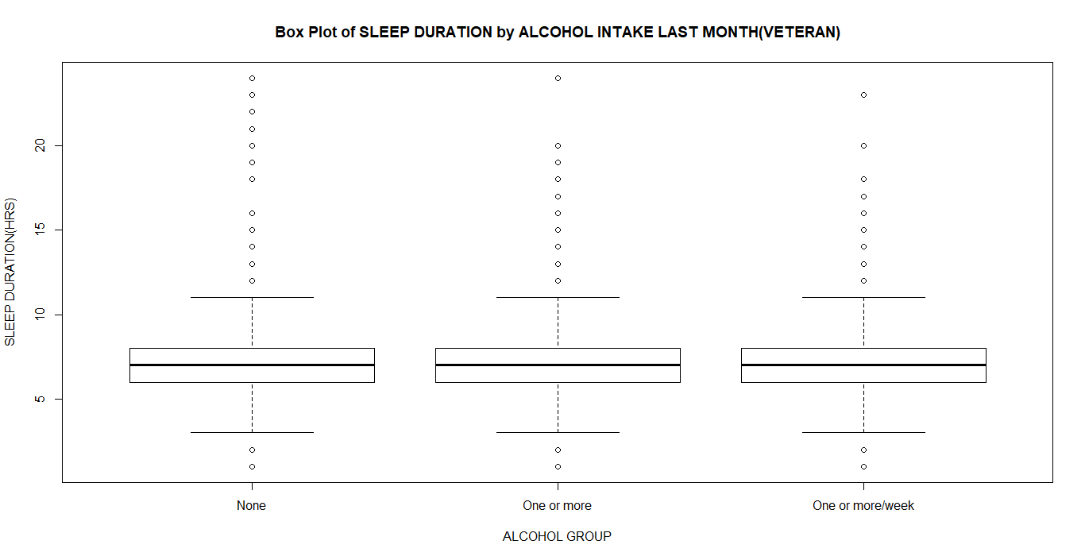

The above boxplot shows a graphical relationship between the sleep duration (in hours) and the alcohol classifications in veterans. Based on the boxplot, there are no perceived differences in sleep duration when associated with the weekly, monthly or non-intake of alcohol in veterans.

**Figure 2: Boxplot showing the association between the age groups intake in veterans (n=60109) and sleep time in hours**

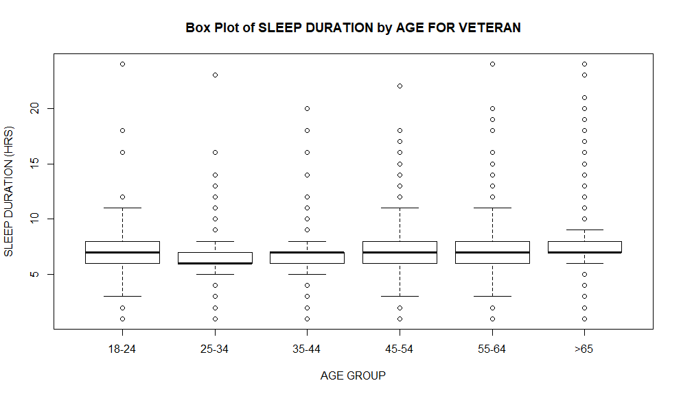

From the above boxplot, the median sleep duration in the 25-34 age groups is the lowest of the sleep categories. The >65 years age group meanwhile contains individuals with the highest sleep duration in veterans. These variations were not observed in non-veterans, as the median for the sleep duration was consistent across the different age groups shown below in figure 3.

**Figure 3: Boxplot showing the association between the age groups intake in non-veterans (n=416404) and sleep time in hours**

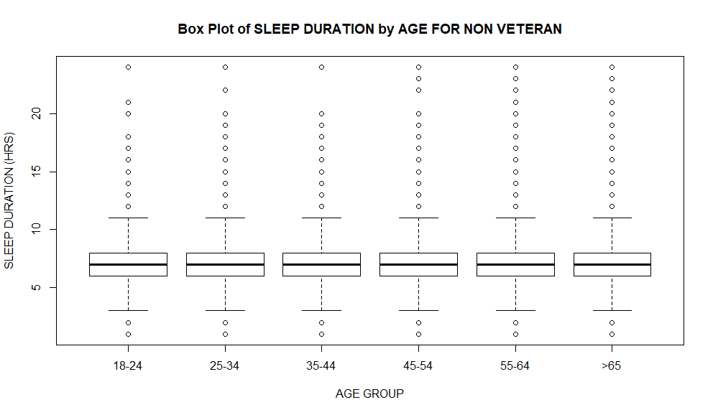

**Table 2: Initial linear regression model showing an association between alcohol intake status and sleep duration in hours in veterans using BRFSS data 2016.**

|  |  |  |  |  |  |  |
| --- | --- | --- | --- | --- | --- | --- |
| **Independent Variables** | **Coefficient estimate** |  | **Confidence levels(95%)** |  | **Standard error** | **p.value** |
| BINGE DRINKING | -0.2536459 |  | - 0.29425 | -0.21294 | 0.02076661 | <0.001 |
| DRANK MONTHLY | -0.071649532 |  | -0.107501281 | -0.0357978 | 0.018291676 | <0.001 |
| DRANK WEEKLY | -0.002194004 |  | -0.037276402 | 0.0328884 | 0.017899152 | <0.001 |

The output of the Initial regression model gives an F= 59.49 (p<2.2e-16), which indicates the rejection of the null hypothesis that states that alcohol intake has no effect on the sleep duration of the veterans. The model also shows that the relationship between the sleep duration (dependent variable) and individual independent variable (monthly, weekly alcohol intake and binge drinking) is significant (p<0.05). However, the Adjusted R-squared value of 0.002911 shows that approximately just 0.29% of the variation in sleep time in veterans can be explained by the model with the contained independent variables. Hence, to develop a more robust model, confounding independent variables such as sociodemographic and health status variables that have been associated with sleep duration were added. The result of the final regression model is stated in Table 3.

**Table 3: Results of the multivariate linear regression model to access the independent variables associated with sleep duration (in hours) in veteran using BRFSS data 2016.**

|  |  |  |  |  |  |
| --- | --- | --- | --- | --- | --- |
| **Independent Variables** | **Coefficient Estimate** | **Standard Error** | **Confidence Levels (95%)** |  | **p.value** |
| DRANK MONTHLY | -0.035056269 | 0.017830325 | -0.070003767 | -0.000108771 | 0.049291217 |
| BINGE DRINKING | -0.010947778 | 0.020750988 | -0.051619785 | 0.02972423 | 0.597793781 |
| DRANK WEEKLY | -0.008289287 | 0.018252232 | -0.044063725 | 0.027485151 | 0.649721082 |
| AGE(55-64years) | 0.308933601 | 0.019640673 | 0.270437813 | 0.347429389 | <0.001 |
| AGE(>65years) | 0.745925391 | 0.015817538 | 0.714922963 | 0.77692782 | ` |
| HISPANIC | -0.079876398 | 0.032315583 | -0.143215053 | -0.016537743 | 0.013447687 |
| BLACK | -0.130621208 | 0.023916649 | -0.177497923 | -0.083744492 | <0.001 |
| ASIAN | -0.331981299 | 0.061035358 | -0.451610813 | -0.212351785 | <0.001 |
| OTHER RACES | -0.175777661 | 0.027009454 | -0.228716283 | -0.122839038 | <0.001 |
| FORMERLY MARRIED | -0.036804482 | 0.014111224 | -0.06446253 | -0.009146435 | 0.009105002 |
| NEVER MARRIED | -0.098719744 | 0.048825227 | -0.194417358 | -0.003022131 | 0.043191067 |
| COLLEGE | -0.058335466 | 0.013303578 | -0.084410526 | -0.032260407 | <0.001 |
| OVERWEIGHT | -0.09085442 | 0.015140491 | -0.120529835 | -0.061179006 | <0.001 |
| OBESE | -0.132342806 | 0.016478637 | -0.164640992 | -0.10004462 | <0.001 |
| SMOKER | -0.170546133 | 0.018144394 | -0.206109207 | -0.134983058 | <0.001 |
| FAIR HEALTH | -0.182325388 | 0.017688792 | -0.216995481 | -0.147655295 | <0.001 |
| POOR HEALTH | -0.203661525 | 0.026032198 | -0.254684722 | -0.152638327 | <0.001 |

The output of the regression model gives an F= 209.7 (p<2.2e-16), which indicates the rejection of the null hypothesis that states that the combined variables in the model have no effect on the sleep duration of the veteran. The model also shows that the relationship between the sleep duration (dependent variable) and the individual independent variables are significant (p<0.05), except in binge drinking and drank weekly variables where the p>0.05. However, the Adjusted R-squared value of 0.0557 shows that approximately just 5.57% of the variation in sleep time in veterans can be explained by the model with the contained independent variable.

**DISCUSSION**

Based on the linear regression models, conclusions were made that alcohol intake only cannot explain sleep duration differences in veterans because the independent variable (weekly and monthly alcohol intake and binge drinking) does not significantly affect the dependent variable (sleep duration) in the population chosen (veterans). To develop a more robust model, other variables were added other variables such as age, health status, smoke status etc. which according to previous studies such as the one published by Faetsel et al in 2013 showed that there is an association with sleep duration.

The initial model only explained about 0.29% variation in the dependent variable while the final model only explains about 5.57% variation in the dependent variable (sleep duration ); hence, my initial assumption that hours of sleep is affected by the alcohol intake in veterans is not strongly supported by the models. Although, the linear regression model did not establish a strong association between alcohol intake and sleep duration, the descriptive analysis clearly shows that younger veterans (25-34years) slept for lesser hours (6.5hours) than older ones (>65), who slept for a mean duration of 7.4 hours. This was not the case in the non-veteran population. Smoke status, race and binge drinking also showed some associations with sleep duration in the study population. The average recommended sleep time is about 7-9hours per day. Findings from this study were different from that of Roehrs et al in 2001. Roehrs et al, 2001 in their work, reported an earlier study that concluded that participants who had earlier onset age of alcohol drinking and drank more per month reported needing only 6 hours of sleep or less while individuals with lower alcohol intake reported needing more than 6hours of sleep. Roehrs et al, therefore, showed that drinking history could play a major role in the effect of alcohol on sleep duration. This variable was not accounted for in this study. Although this work established significant relationships between sleep duration and other variables such as monthly and weekly alcohol intake, binge drinking, age, economic and health status, a linear regression model that strongly associates these variables with sleep duration could not be made. Looking into previous studies, this is very understandable as there are a lot of other factors that could affect sleepiness and sleep duration in individuals. Such factors could be physiological (pain), psychological (such as anxiety), medications and substances (such as caffeine), light, jet lag, shift work, sleep environment etc. Since sleep duration could be affected by all these factors, therefore, it would have been more surprising to have had a linear regression model that established a very strong association, more than the one obtained in this study when all these factors are considered. It is also worthy to note that the population being studied contained 60109 individuals, this also adds to the complexity of developing a model. Although, the multivariate linear regression model developed in this study fails to establish a strong association between the drinking status and sleep duration, other variables not contained in this study have been shown by other studies to affect sleep duration in humans. The exclusion of these variables constitutes a limitation for this study.

**REFERENCES**

About BRFSS. (May 2014). Retrieved from <https://www.cdc.gov/brfss/about/index.htm>

Bohnert, A. S., Ilgen, M. A., Bossarte, R. M., Britton, P. C., Chermack, S. T., & Blow, F. C. (2012). Veteran status and alcohol use in men in the United States. *Mil Med, 177*(2), 198-203.

David W Browna, L. S. B., Wayne H Giles, Gloria L Beckles, David G Moriarty, Earl S Forda, Ali H Mokdada. (2004). Diabetes mellitus and health-related quality of life among older adults: Findings from the behavioral risk factor surveillance system (BRFSS). *Diabetes Research and Clinical Practice*

*65*(2), 105-115.

Faestel, P. M., Littell, C. T., Vitiello, M. V., Forsberg, C. W., & Littman, A. J. (2013). Perceived insufficient rest or sleep among veterans: Behavioral Risk Factor Surveillance System 2009. *Journal of clinical sleep medicine : JCSM : official publication of the American Academy of Sleep Medicine, 9*(6), 577-584. doi:10.5664/jcsm.2754

Galbicsek, C. (2018). Alcoholism in Veterans. Retrieved from <https://www.alcoholrehabguide.org/resources/alcoholism-in-veterans/>

Geiger, S. D., Sabanayagam, C., Shankar, A. J. J. o. e., & health, p. (2012). The relationship between insufficient sleep and self-rated health in a nationally representative sample. *2012*.

Grandner, M. A., Patel, N. P., Gehrman, P. R., Xie, D., Sha, D., Weaver, T., & Gooneratne, N. J. S. m. (2010). Who gets the best sleep? Ethnic and socioeconomic factors related to sleep complaints. *11*(5), 470-478.

Javierde Miguel Dieza, R. J. G., Valentin Hernandez Barrera, Paula Rodríguez Rodrígueza, Luis Puente Maestua, Pilar Carrasco Garrido. (2012). Mental health among adults with asthma and chronic bronchitis. A population-based study in Spain. *Respiratory Medicine, 106*(7), 924-932.

kassambara. (2018). Multiple Linear Regression in R.

Liu, Y., Croft, J. B., Wheaton, A. G., Perry, G. S., Chapman, D. P., Strine, T. W., . . . Presley-Cantrell, L. J. B. p. h. (2013). Association between perceived insufficient sleep, frequent mental distress, obesity and chronic diseases among US adults, 2009 behavioral risk factor surveillance system. *13*(1), 84.

Liu, Y., Wheaton, A. G., Chapman, D. P., & Croft, J. B. (2013). Sleep duration and chronic diseases among U.S. adults age 45 years and older: evidence from the 2010 Behavioral Risk Factor Surveillance System. *Sleep, 36*(10), 1421-1427. doi:10.5665/sleep.3028

Liu, Y., Wheaton, A. G., Chapman, D. P., & Croft, J. B. J. S. (2013). Sleep duration and chronic diseases among US adults age 45 years and older: evidence from the 2010 Behavioral Risk Factor Surveillance System. *36*(10), 1421-1427.

Roehrs, T., Roth, T. J. A. r., & Health. (2001). Sleep, sleepiness, and alcohol use. *25*(2), 101-109.

Strine, T. W., & Chapman, D. P. J. S. m. (2005). Associations of frequent sleep insufficiency with health-related quality of life and health behaviors. *6*(1), 23-27.

*Suicide Among Veterans and Other Americans 2001–2014*. (2016). Retrieved from <https://www.mentalhealth.va.gov/docs/2016suicidedatareport.pdf>